Answer 7
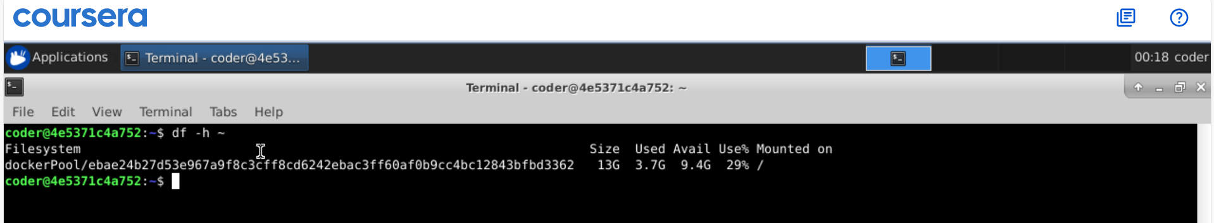
Explanation: disk space usage can be checked with df command and using -h option we can get human readable size. We use ~ for home directory.

